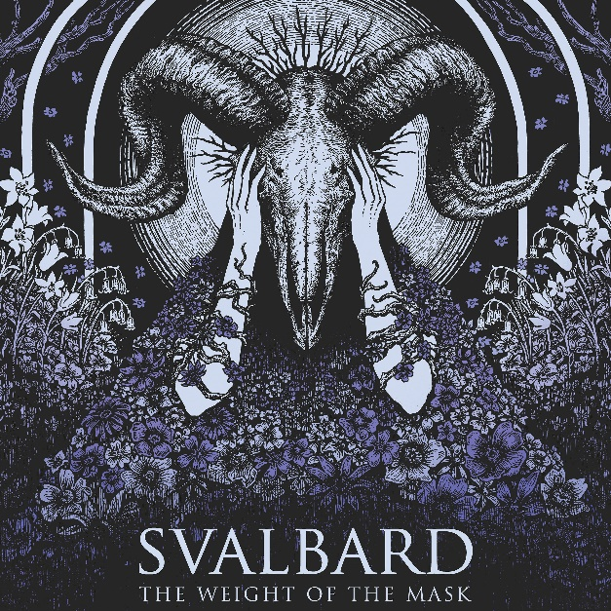

SVALBARD
The Weight Of The Mask
OCTOBER 6TH 2023
Line up:  Serena Cherry – Vocals/Guitar  Liam Phelan – Vocals/Guitar  Mark Lilley – Drums  Matt Francis – Bass | SVALBARD online:  https://facebook.com/svalbarduk  https://twitter.com/Svalbardband  https://instagram.com/svalbardt
You'd be forgiven for struggling to summarise the sound of Svalbard in a few words. Since forming in 2011, the band have had their hands in black metal, post-rock, d-beat, shoegaze, hardcore, and post-metal. Whilst their music stubbornly refuses to fit neatly into one genre, one word remains a fitting adjective for the British quartet: unique. Svalbard spent their early years playing DIY shows, releasing 3 EPs, and honing their sound, before eventually dropping their debut album One Day All This Will End in 2015. Since then, Svalbard gained the momentum of a runaway freight train, releasing two further albums whilst continuing to refine their vast array of musical influences; drawing from video game soundtracks, grindcore and dream pop all buried within a distorted yet dynamic sound. But they're not just heavy in the musical sense of the word. No one articulates the reality of mental illness as succinctly as Svalbard. With 2020's When I Die Will I Get Better the band cut so deep both musically and lyrically that it raised the questions: where can Svalbard possibly go from here? How do you follow up an album created at the darkest point of your life? If this were a Disney movie, this would be the point where we say that new record The Weight of the Mask is the light piercing through the dark clouds, the hope returning into your heart, the promise of a happy ending… Well. It's not. The depression did not simply go away. It clinged like a limpet, it morphed over lockdown after lockdown, it grew into a beast. But it's a beast that Svalbard no longer fears. If the previous record was about facing your demons, then this album is about fighting them with everything you've got.
Written in the band's freezing cold rehearsal room in Bristol - which required two members to drive 120 miles from London every weekend - the album did not come together painlessly. The pressure of the success of their fourth album was daunting and the band's response was to take an extremely meticulous approach to writing new material. "I've lost count of the amount of times these songs changed," joked Serena Cherry (lead guitar/vocals) "but in that process of deeply analysing each musical idea we certainly learned how to get the best from each other”. The band were keen to work with producer Lewis Johns again, as he truly understands both the heaviness and the beauty in Svalbard's sound. Lewis makes the band feel comfortable enough to draw out their darkest emotions when recording, with Serena admitting she "cried in the vocal booth when recording the lyrics to all of these songs”.
With a fourth album now under their belts, Svalbard are going from strength to strength - not just as one of the brightest sparks in metal and contemporaries of a burgeoning modern British metal scene, but as advocates for mental health.

